OKANAGAN SIMILKAMEEN STEWARDSHIP SOCIETY
Voluntary Wildlife Habitat Steward Agreement

Name:
Civic Address:
Mailing Address (if different):
Phone:
E-mail:
Do you prefer contact by email or phone? _______________

Would you like to receive our semi-annual e-newsletter? Circle one: Yes No

Would you like to become a member of Okanagan Similkameen Stewardship ($10.00/year)?
Circle one: Yes No

Under this voluntary agreement:
- Okanagan Similkameen Stewardship Society agrees to the following as capacity allows:
  - Provide information and/or advice regarding wildlife, habitat, and stewardship options to the landowner when requested.
  - Provide landowner with information, technical assistance and support with habitat enhancement within the stewarded area as capacity allows [and as appropriate according to our guidelines], including: (select all that apply)
    - Compiling a baseline ecological summary of property including best management practices for wildlife
    - Planting of native species
    - Invasive species management plans
    - Fencing of ecologically sensitive areas to exclude livestock and/or trespass
    - Provide wildlife residence boxes for installation
    - Other (please describe):
  - Provide landowner with a Wildlife Habitat Steward gate-post sign.
  - Check in with landowner through email or phone at least once per year to answer questions and/or make recommendations if requested
  - Conduct site visits to the property as requested by landowner

- The landowner(s) agree(s) to manage the stewarded area in the following way:
  - Managing the spread of invasive and noxious species:
    - Not planting invasive plant species within the stewarded area.
    - Not introducing fish/turtles/other non-native wildlife to the stewarded area
  - Assisting OSS with habitat enhancement efforts on their property(ies), including: continuation of OSS invasive plant removal efforts on their own time, taking bags of invasive species to the landfill, watering planted areas when possible, assisting with planting days, and any other activities agreed upon by both parties.
  - Not filling in or draining any wetland area.
  - Installing any wildlife habitat features (nest boxes, bat boxes, turtle basking structures) within one month of receipt and reporting use (or not) by wildlife when requested of OSS staff.
  - Not removing native plant vegetation within the Stewarded Area unless it poses a risk to health and safety or is prescribed in order to reduce encroachment of grasslands.
  - Contacting Okanagan Similkameen Stewardship Society if there are any threats to or concerns about the stewarded area.
  - Contacting Okanagan Similkameen Stewardship Society if the property is to be sold (to aid in continuity with new property managers).

3. Confidentiality & Privacy & Recognition
Okanagan Similkameen Stewardship Society can share the details of this agreement and your involvement in the program with: (please initial next to your response)
a) Species at Risk Recovery Teams
_______ Agree ______Do not agree
b) South Okanagan Similkameen Conservation Program and/or Okanagan Collaborative Conservation Program partners
_______ Agree ______Do not agree

4. Recognition and Outreach
Okanagan Similkameen Stewardship Society can share your involvement in the program with the public and on tabletop displays and brochures.
_______ Agree ______Do not agree

- Property Access
Any and all access to private property must be requested of and approved by the landowner(s). All requests will be made with reasonable advance notice by Okanagan Similkameen Stewardship representatives. The landowner(s) retain(s) all rights to restrict access to their private property.

I (we) understand that this voluntary agreement does not involve any loss of ownership rights. It only serves to indicate my (our) intention to conserve native habitat and wildlife.

Okanagan Similkameen Stewardship Society
#6 – 477 Martin Street
Penticton, BC V2A 5L2
E: info@osstewardship.ca P: 250-770-1467

____________________________________ _______________________
Signature of landowner Date

____________________________________ _______________________
Signature of OSSS Representative(s) Date

Property Overview and Information

Property Location (directions & overview map):

Site Map: Property outlined in yellow, stewarded area outlined in red

Description of the stewarded area:
Property Identifier (PID):
Approximate size (ha):
Habitat type(s):
Potential projects:

Potential wildlife and/or species-at-risk occurrences/observations
Species Name | Federal &/or Provincial status | Observer & Date or potential | Management Recommendations
American Badger  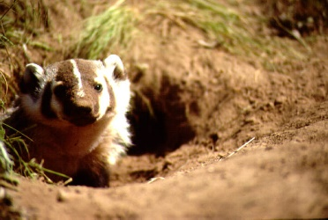 | F: Endangered  P: Red List |  | - Maintain large tracts of key habitat, particularly open grassy areas with soils suitable for excavating burrows.  - Employ grazing management practices that promote the growth of healthy native grassland communities.  - Carefully monitor the use of rodenticides.  - Support prescribed burning programs.  - Encourage landowners to adopt a more sympathetic attitude towards Badgers and ground squirrels.  - Report any observations of shooting, trapping, or harassment.
Blotched Tiger Salamander  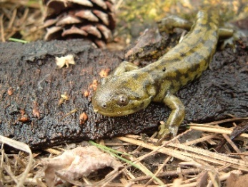 | F: Endangered  P: Red List |  | - Fence ponds and lakes to exclude livestock  - Maintain water levels of ponds and irrigation reservoirs whenever possible  - Create ponds to compensate for loss of natural breeding habitat  - Protect riparian areas and shrub-grasslands to provide migration corridors and feeding areas  - Do not stock salamander breeding ponds or lakes with game fish  - Ensure irrigation intake lines are screened
Great Basin Spadefoot  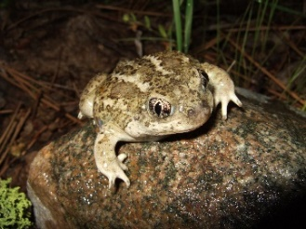 | F: Threatened  P: Blue List |  | - Protect major breeding sites and surrounding foraging habitat.  - Fence ponds and lakes to exclude livestock.  - Maintain water levels whenever possible.  - Create ponds to compensate for loss of natural breeding habitat.  - Install culverts under roads and amphibian fences along roads near areas with high numbers of toads.  - Do not stock ponds or lakes with game fish.
Western Painted Turtle  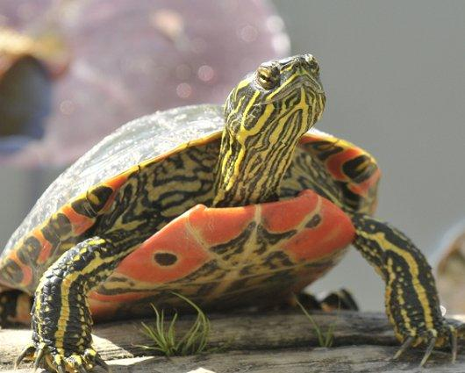 | F: Special Concern  P: Blue List |  | - Protect key habitat including remaining wetlands, ponds and other small waterbodies.  - Restrict the development of roads, trails, beaches and campgrounds in key turtle habitat.  - Observe turtle basking sites from a distance and avoid nest sites.  - Keep dogs leashed near turtle habitat and don't pick up turtles.  - Restore degraded wetlands, provide basking logs and create nesting sites.  - Erect fences around wetlands and known nesting habitat to prevent trampling by livestock and damage by all-terrain vehicles.  - Take unwanted, non-native turtles to the SPCA; do not release into the wild.
Great Basin Gopehersnake  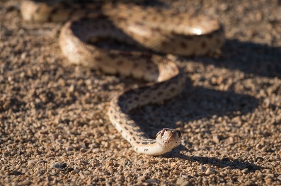 | F: Threatened  P: Blue List |  | - Identify and protect dens and nesting sites whenever possible.  - Leave 1 km buffer zone around known den sites and critical habitats.  - Avoid road construction near talus slopes and around known snake dispersal routes.  - Avoid disturbing rock and woody debris in potential snake habitat.  - Maintain good range condition in grasslands for cover and habitat for prey species.
Western (Northern Pacific) Rattlesnake  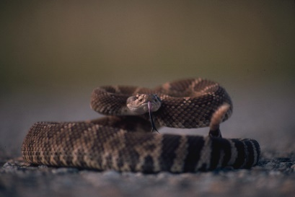 | F: Threatened  P: Blue List |  | - Leave 1 km buffer zone around known den sites and critical habitats.  - Avoid road and skid trail construction near potential den sites such as rock outcroppings and talus slopes, and around known snake dispersal routes.  - Avoid disturbing rock and woody debris in potential snake habitat.  - Maintain good range condition in grasslands for cover and prey species.
Yellow-bellied Racer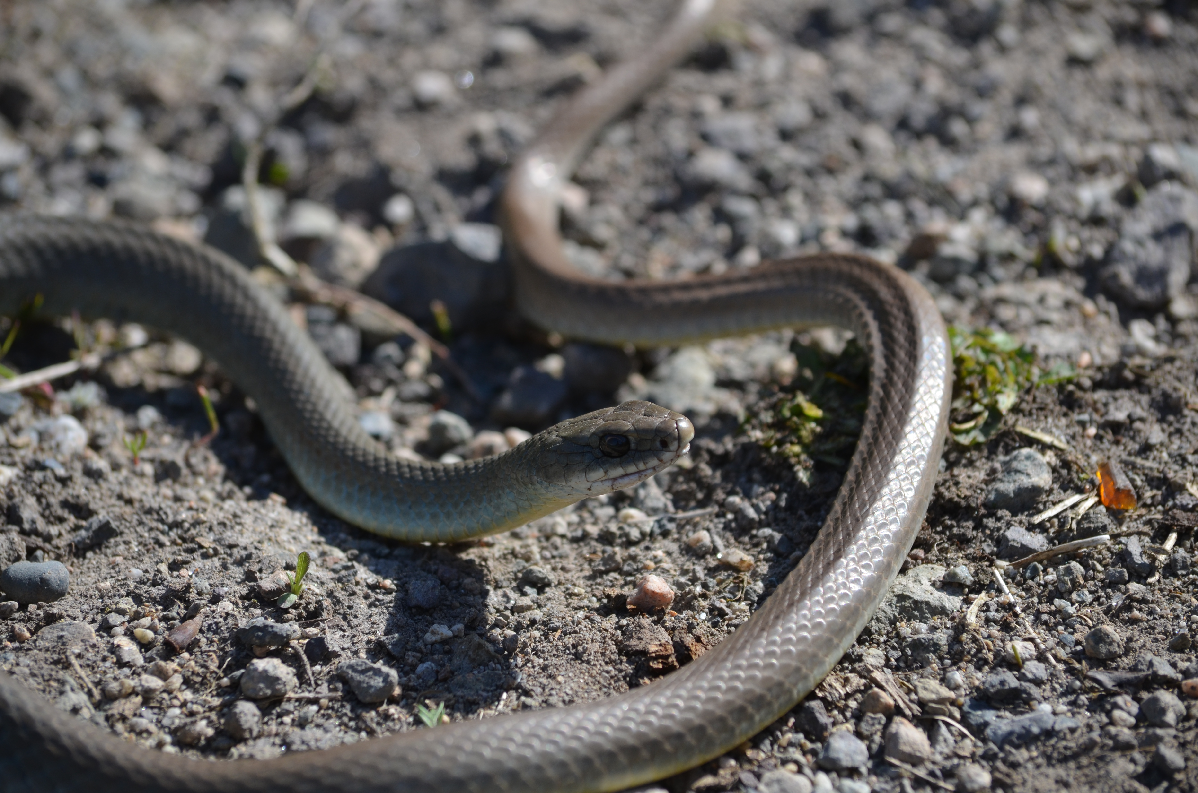 | F: Threatened  P: Blue list |  | - Identify and protect dens and nesting sites whenever possible.  - Leave 1 km buffer zone around known den sites and critical habitats.  - Avoid road construction near talus slopes and around known snake dispersal routes.  - Avoid disturbing rock and woody debris in potential snake habitat.  - Maintain good range condition in grasslands for cover and habitat for prey species.
Western Screech-Owl | F: Threatened  P: Blue List |  | - Maintain patches of mature forest 5-10 hectares in size.  - Retain large, standing coniferous and deciduous trees in riparian habitats.  - Where large, standing deteriorating trees have been felled, allow a new generation of trees to develop; in the meantime, construct and erect owl boxes to provide suitable nesting sites.
Flammulated Owl  A tiny owl; length 15 cm, weight 50 - 65 gm | F: Special Concern  P: Blue List |  | - Protect remaining old-growth ponderosa pine and Douglas-fir forests.  - Leave snags and some large pines and firs when selectively logging a site; this can be done by choosing wildlife tree patches that contain suitable nesting snags.  - Set up nest boxes in forests that have few or no suitable nest sites.  - Avoid use of pesticides in Flammulated Owl habitat
Yellow-breasted Chat  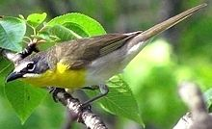 | F: Endangered  P: Red list |  | - Maintain and enhance remaining riparian habitat including cottonwoods, aspen, rose thickets and snowberry.  - Avoid clearing or thinning shrubs and thickets in riparian areas.  - Fence riparian areas to prevent livestock from trampling bushes or employ a carefully managed grazing strategy.  - Prevent off-road vehicles from disturbing and degrading stream-side vegetation.  - Protect known breeding sites from human disturbance.
Williamson’s Sapsucker  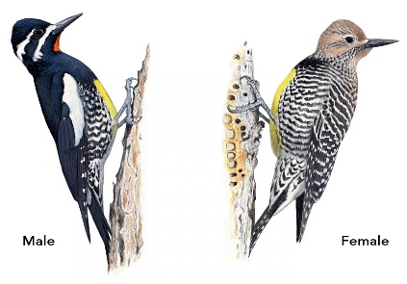 | F: Endangered  P: Blue List |  | - Critical Habitat Identified and posted  - Retain dead and dying trees where it is safe to do so  - Avoid use of pesticides in Williamson Sapsucker habitat  - Do not harvest large live trees or dead standing trees for firewood
Lewis’ Woodpecker  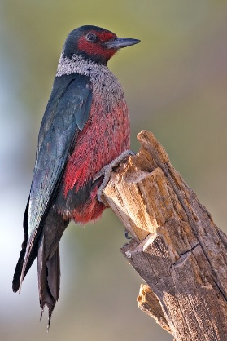 | F: Threatened  P: Blue Listed |  | - Avoid frequent or prolonged human disturbance at nest sites during the breeding season (May-August)  - Preserve and maintain ponderosa pine forests and black cottonwood stands.  - Protect known nest sites.  - Maintain dead or dying standing trees, especially soft, large diameter snags.  - Monitor and reduce the use of pesticides.
White-headed Woodpecker  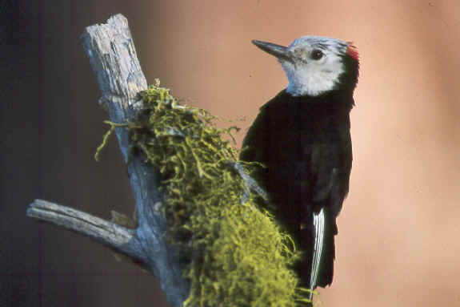 | F: Endangered  P: Red list |  | - Encourage selective logging practices rather than clear-cutting; logging can serve to thin dense stands nearing maturity and remove competing trees.  - Improve and sustain old growth ponderosa pine forest.  - Allow successional forest stages to mature to old growth.  - Thin young stands to maximize growth and cone production.  - Retain dead or dying standing trees, especially soft, large diameter snags.  - Discourage use of forest insect pesticides in their habitat.  - Support prescribed burning programs
Little Brown Myotis  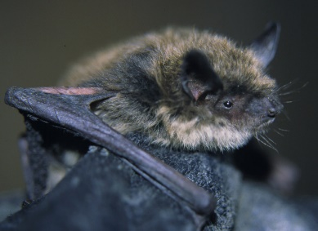 | F: Endangered  P: Yellow List |  | - Avoid the use of pesticides, particularly near wetlands and riparian areas.  - Protect important habitat such as low elevation forest, grassland, and riparian areas.  - Establish a buffer zone of at least 100 metres around roosting sites.  - Preserve old mine shafts, but erect gates to prevent human access to caves and mine sites.  - Refrain from entering caves or mine shafts, particularly during winter months when bats are hibernating.
Pallid bat  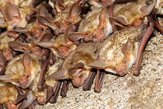 | F: Threatened  P: Red list |  | - Avoid the use of pesticides, particularly near wetlands and riparian areas.  - Protect known roosting sites from disturbance.  - Preserve old mine shafts, but erect gates to prevent human access to caves and mine shafts.  - Maintain water levels in ponds as sources of drinking water and foraging areas.  - Discourage, free-roaming domestic cats, especially near potential bat habitat.
Half-moon Hairstreak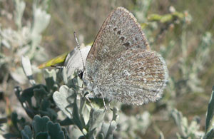 | F: Endangered  P: Red list |  | - Protect host plants where found (lupine)  - Avoid use of insecticides wherever possible, especially in close proximity to known populations  - Support prescribed burns/ controlled burning to keep grasslands open  - Employ grazing management practices that promote the growth of healthy native grassland communities
Behr’s Hairstreak | F: Endangered  P: Red List |  | - Retain antelope brush plant community  - Employ grazing management practices that promote the growth of healthy native grassland communities  - Manage invasive plants  - Reduce/eliminate use of pesticides
Mormon metalmark  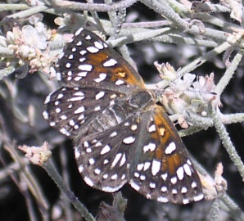 | F: Endangered  P: Red list |  | - Protect host plants where found (snow buckwheat)  - Avoid use of insecticides wherever possible, especially in close proximity to known populations  - Employ grazing management practices that promote the growth of healthy native grassland communities  - Manage invasive plants  - Avoid watering dry gravel areas where snow buckwheat is present

Management Concerns and Recommendations:
Concern (eg. Invasive plants, etc) | Location & Description | Management Recommendations
Common Burdock (biennial to short lived perennial with first year rosette and second year )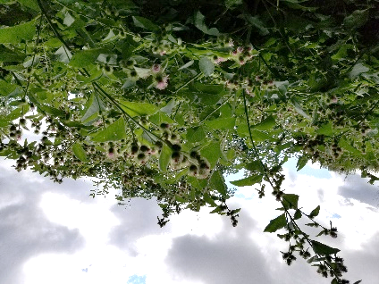 | Infestation is approximately 0.5acres, located along shoreline of XYZ creek at east boundary of property. | Dig at least 6 inches of taproot and re-seed bare soil where possible to encourage desirable, competing vegetation. Plant can be composted but flowers and seeds should be bagged and buried at the landfill.
Hound’s Tongue (Biennial. 3-4 ft. with first year rosette)  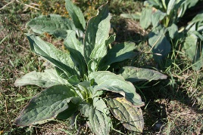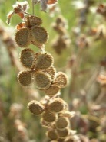 | Description of infestation goes here | Hand pull or dig up at all stages ensuing most/all of root has been removed. Compost only if flower/seed is not present. Remove burrs from self & equipment before leaving site.
Purple Loosestrife (perennial 3-4 ft)  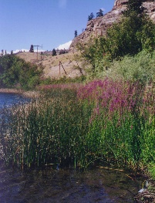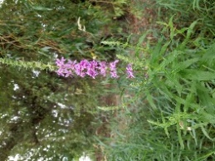 | Description of infestation goes here | Biocontrol has been released in many places throughout Okanagan and Similkameen. Sign of biocontrol includes “shot-holes” through stem/leaves. If no biocontrol present and plants are not in standing water, dig to remove root. Otherwise cut flowering stalks near the base.
Siberian (Russian) Elm (Tree growing up to 25m)  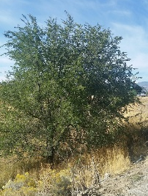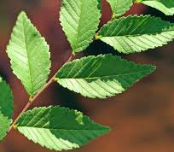 | Description of infestation goes here | Hand pull saplings. Cut down or girdle mature trees and apply systemic herbicide to the stump.
Comfrey (perennial up to 4 ft)  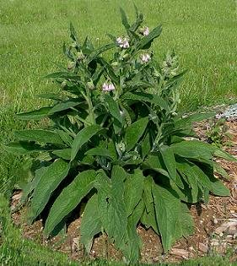 | Description of infestation goes here | Mow or hand pull as much as possible then cover with landscape fabric and leave covered at least 2 growing seasons. Landscape fabric should be overlapped at seams or comfrey will grow through.
Yellow flag iris (perennial up to 5 feet)  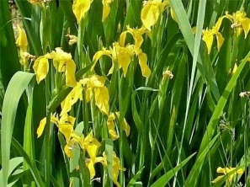 | Description of infestation goes here | Permits may be required due to plants growing in or near water bodies. Repeated cutting or pulling can be effective over time. Digging can be effective but portions of root left behind can spread the plant, ensure you remove as much of the plant as possible.
Sulfur Cinqufoil (perennial 1-2.5 feet tall)  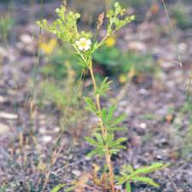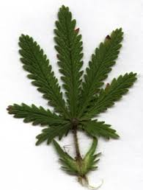 | Description of infestation goes here | Hand pulling can be effective on small infestations. Make sure to get at least the first few inches of root. Mowing is not an effective form of control. With large infestations use of herbicides may be required.
Hoary Alyssum (annual to short-lived perennial 1 – 2.5 feet tall)  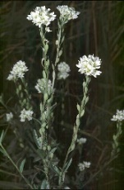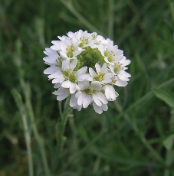 | Description of infestation goes here | Hand pull ensuring entire root is removed. Cut and bag seed heads of mature plants before pulling.
Yellow Salsify (Yellow Goatsbread annual 1-2 feet_  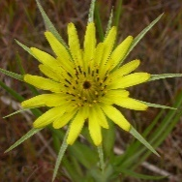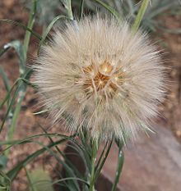 | Description of infestation goes here | Annual weed, not highly concerning. Hand pull before plants go to seed. It becomes more difficult to remove the entire root as the plant matures. Once the plant has gone to seed bag seed head prior to pulling.
Livestock access to creek | Cattle are currently allowed free access to creek. | Livestock exclusion fencing with nose-in to allow for limited access along creek recommended leaving a minimum 30m buffer. If void of all riparian vegetation, may recommend planting of native species in fenced area.
Trespass.  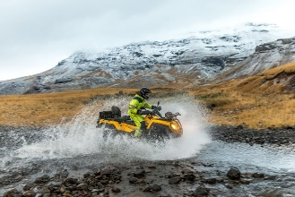 | Description of trespass goes here | Trespass by unauthorized ATV users, dirt bikers, hunters, hikers, naturalists or others can cause damage to sensitive ecosystems. Fencing access areas and signage may be appropriate.
Excessive Trail creation  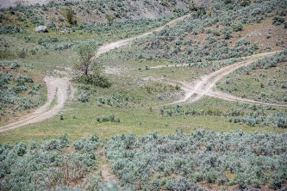 | Description of trail network goes here | A few trails to access/enjoy your property. Creating trails through sensitive habitats can limit damage to soil crusts and sensitive plants. Too many trails especially parallel trails or very steep trails can cause unnecessary environmental damage closing certain trails may be appropriate, other restoration activities may be necessary.
Lack of Riparian Buffer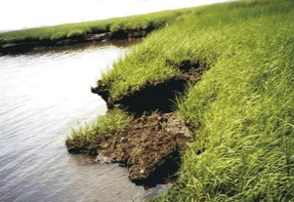 | Lack of thick diverse buffer of native species along shorelines or watercourses | Planting native plants or establishing no mow zones may be recommended

Restoration Plan (if applicable)

Site description/baseline

Rationale for project

Goals & Objectives of project

Site plan

Action plan
Restoration Activity | Description (lead, partnership, etc) | Date

Monitoring schedule & protocol
Photo point monitoring
Before/after photos

Maintenance

